*Software Requirements Specification****HOTEL BOOKING APP***

**Document ID:** Assignment 1

**Author(s): SENTHIL KUMAR T**

**Version:** 0.2

**Date:** March 14, 2024

**1. Objective and Scope 3**

**2. Project End Users 3**

**3. Features 4**

3.1 Login to the system

3.2 Flow Chart

3.3 Add Users

3.4 Booking Room

3.5 Room Reservation Details 6

3.6 Feedback from Guest 7

**4.** **Reports** **7**

# 1.Objective and Scope

* Hotel Booking App is a web-based application that enables users to book hotel accommodations conveniently.
* It allows users to search and book hotel rooms based on their preferences and availability.
* Users can view details about available rooms, including room types, amenities, and prices.
* The system provides users with the ability to modify or cancel their bookings as needed.
* Hotel Booking App offers users the option to make payments securely within the application.
* This document outlines the functional and non-functional requirements for HotelBooking App.

# 2 .Project End Users

The Hotel Booking App must be downloaded and installed on end users devices. The application interface must be simple and visually appealing to improve usability and be easy to use.

# 3.Features

## 3.1 Login to the system

To minimize the possibility of user abandonment as a result of drawn-out sign-up procedures by guaranteeing a smooth and hassle-free login experience for users.

* Users shall be able to create an account using their email address, phone number, and password.
* The system shall provide a secure login process where users can access their accounts using their credentials.
* Users shall have the ability to reset their password securely in case it is forgotten, with appropriate verification measures in place to ensure account security.

## 3.2 Flow Chart

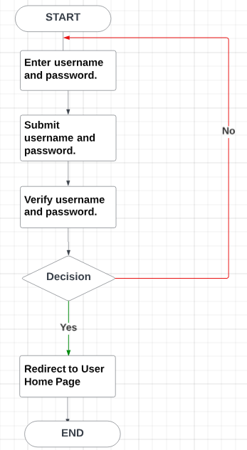

## 3.3 Add Users

Users are added into the database while there are signing up. Before adding theuser, it allows the user to check for any duplicates in the database.

## 3.4 Booking Room

* The system will take the user to the home screen after the registration procedure is successfully completed.
* From the home screen, users can initiate the process of booking rooms according to their requirements.
* Users will have the ability to specify their desired check-in and check-out dates, as well as any specific room preferences.
* Utilizing GPS functionality in the user's device, the system will track the user's current location to provide tailored recommendations or assistance during the room booking process.
* Once the user selects a room , confirms the booking details and after payment , the system will process the reservation and generate a booking confirmation for the user.

## 3.5 Room Reservation Details

* The system will display real-time information regarding the status and location of the reserved room.
* Guests will be provided with an estimated time of check-in and relevant details about their reservation.
* Guests will have access to room-specific information such as room number and type, along with contact details for the hotel front desk.

## 3.6 Feedback from Guest

* Guests will have the chance to share their thoughts about their experience with the hotel management system if their stay has gone well.
* The feedback submitted by guests will be stored in the system's database for future analysis and reference.
* This feedback mechanism will facilitate continuous improvement of services and enhance guest satisfaction.

# 4.Report

The Hotel Booking App produces detailed reports aggregating guest feedback, occupancy rates, and revenue streams, enabling informed decision-making. Management utilizes these insights to optimize operations, enhance guest experiences, and drive continuous improvement initiatives. Generated reports serve as valuable tools for monitoring performance and identifying trends